**PRESS RELEASE**

**NEWS 2018**

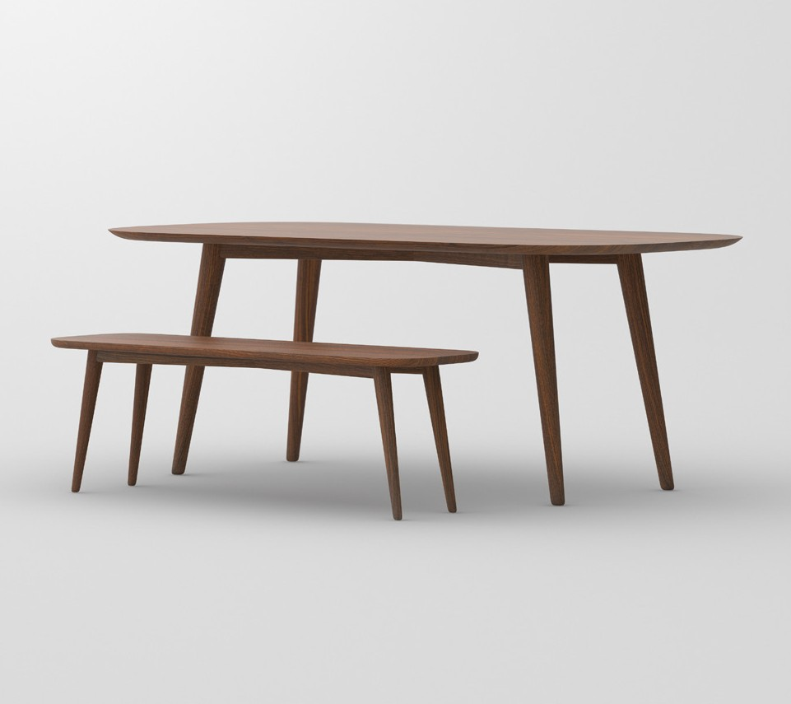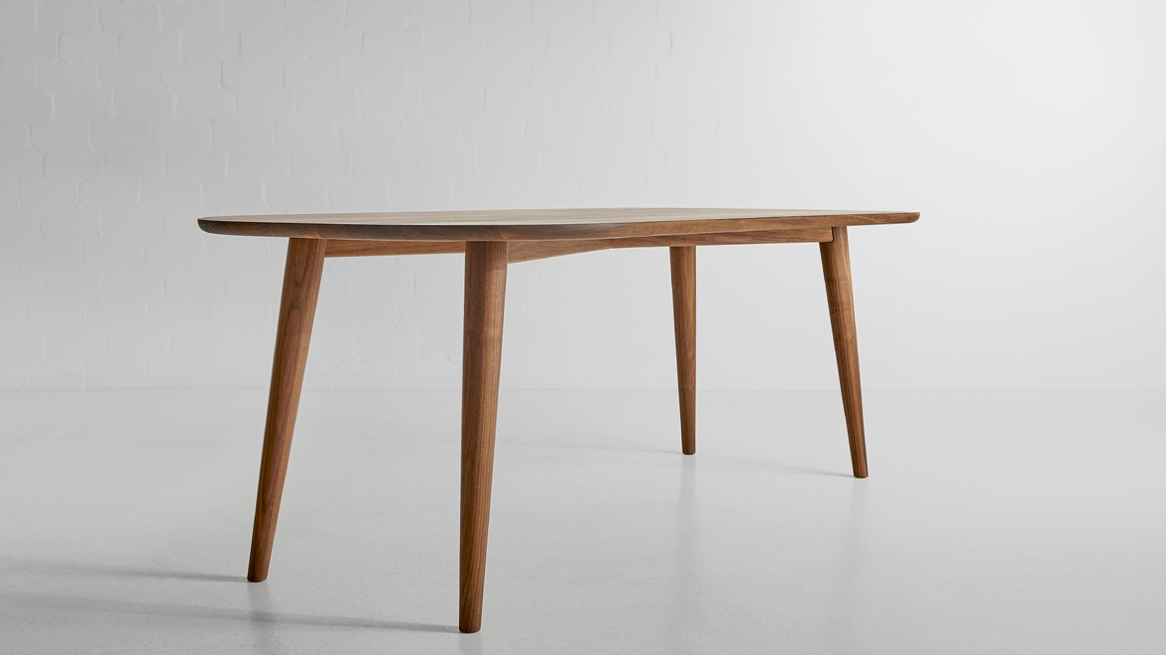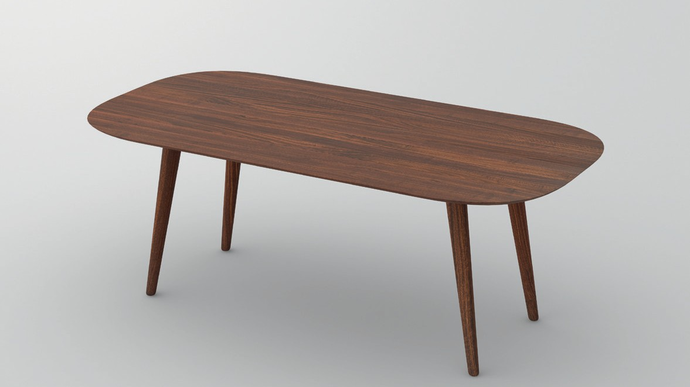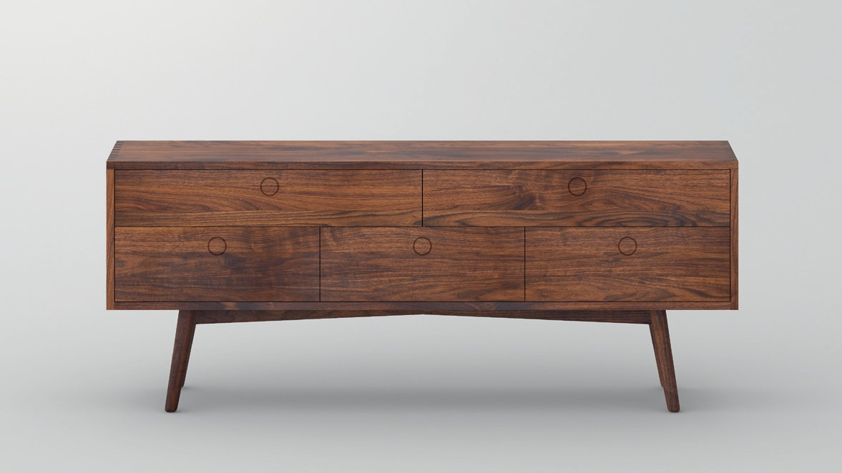

PRESS RELEASE

**AMBIO**

**Contemporary archetypical form with confident character**

The rounded table top form combined with back-turning, slimming legs

builds a harmonic unity. The table Ambio appeals unique and distinct not only in round, but also in oblong shape.

Coffee table, stool and storage furniture have a unique form, they comple-

ment the AMBIO series brilliantly. The elegant leg form lends easiness and airiness to the sto- rage furniture while the internal space is purposefully designed and offers generous storage. Ambio fuses a harmonic and easy optics with the expedience of the furniture. The appearance and highly qualitative workmanship makes this furniture collection to an absolute eye catcher in your home.

The table Ambio had a harmonic modern

appeal with a diagonal crossing frame, combined with a rounded form and the tapering legs on the international jury that bestowed the table with ICONIC AWARDS 2018: Innovative Interior Win- ner.

Available in all solid wood types from

vitamin design collection: European oak and knotted oak, ash, beech, core beech, American maple, walnut and cherry wood, treated with herbal oil.

Sample pricing:

Table made of solid American walnut,

180 x 90 cm 2707 Euro

Sideboard made of solid American walnut,

200 x 46 x 80 cm 4871 Euro

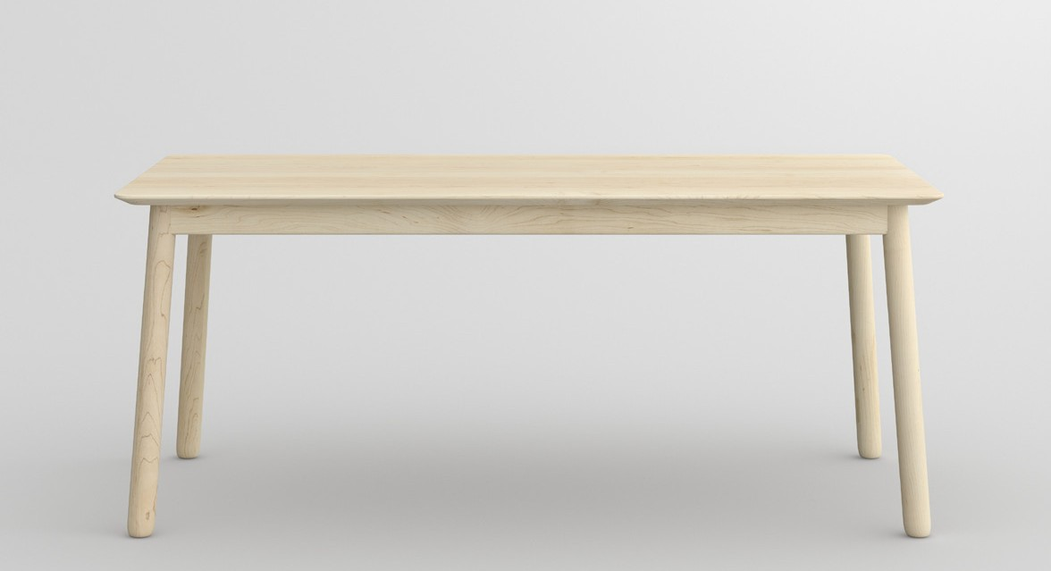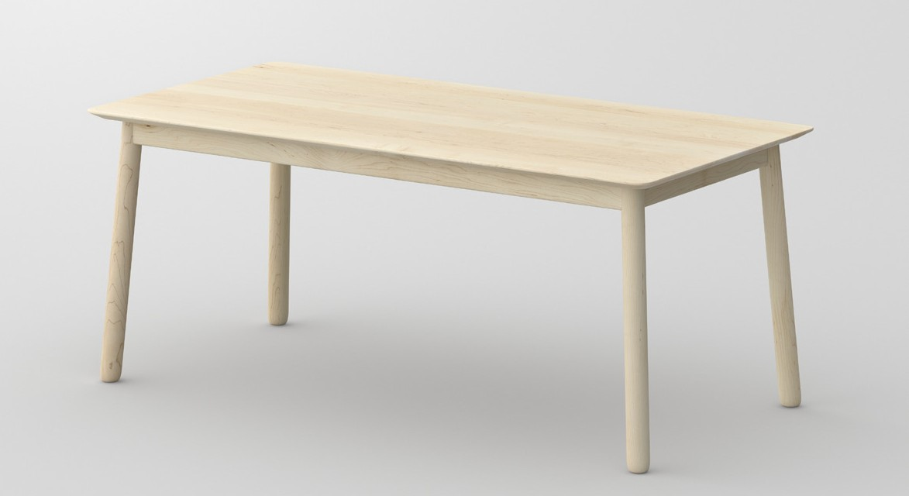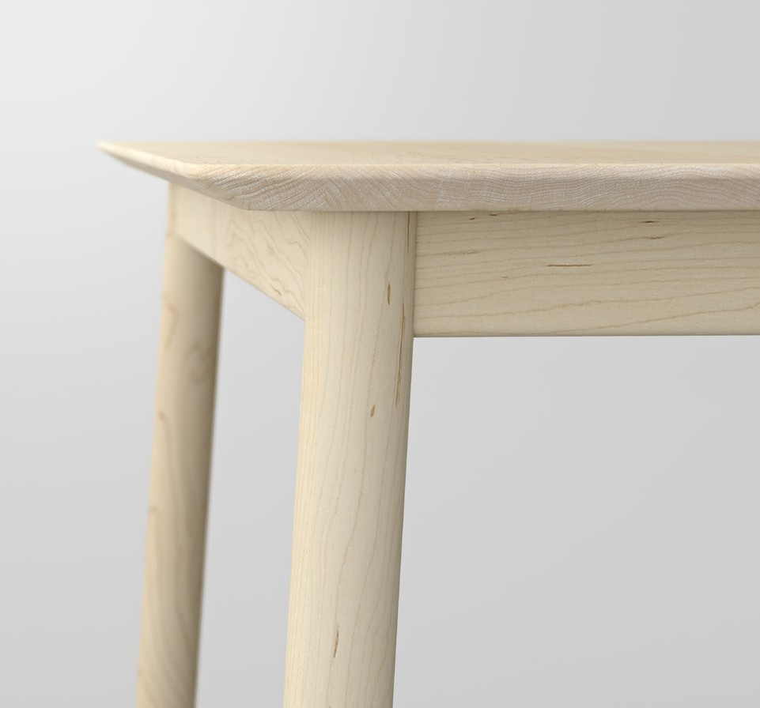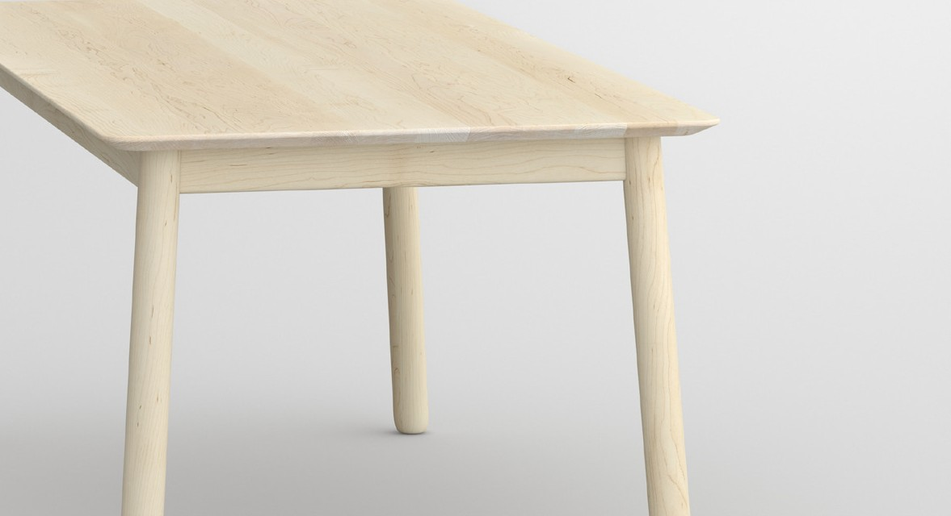

PRESS RELEASE

**LOCA**

**Stylish and timelessly modern appearance**

The rating „Special Mention“ honors works, which design have exceptionally

great partial aspects or solutions – an award, that acknowledges the dedication of companies and designers. LOCA is an elegant table that fits perfectly into your dining room. An ingenious profile of the table top combined with round legs. The slanted edge creates a flowing transition between the table top and the legs. With its timely design, the table provides a classy ambience for every living room. Available in all solid wood types from vitamin design collection in standard or custom sizes.

The design concept convinced the ex-

perts of the German Design Council for “German Design Award 2018: Special” in the category “Excellent Product Design”. Statement of the jury: With its clean forms, this table features a stylish and timelessly modern appearance, allowing

it to fit in a wide range of interior design

styles.

Available in all solid wood types from vita-

min design collection in standard or cus- tom sizes from European oak and knotted oak, ash, beech, core beech, American maple, walnut and cherry wood, treated with herbal oil.

Sample pricing:

Table made of solid American maple, chalked 180 x 90 cm 1731 Euro

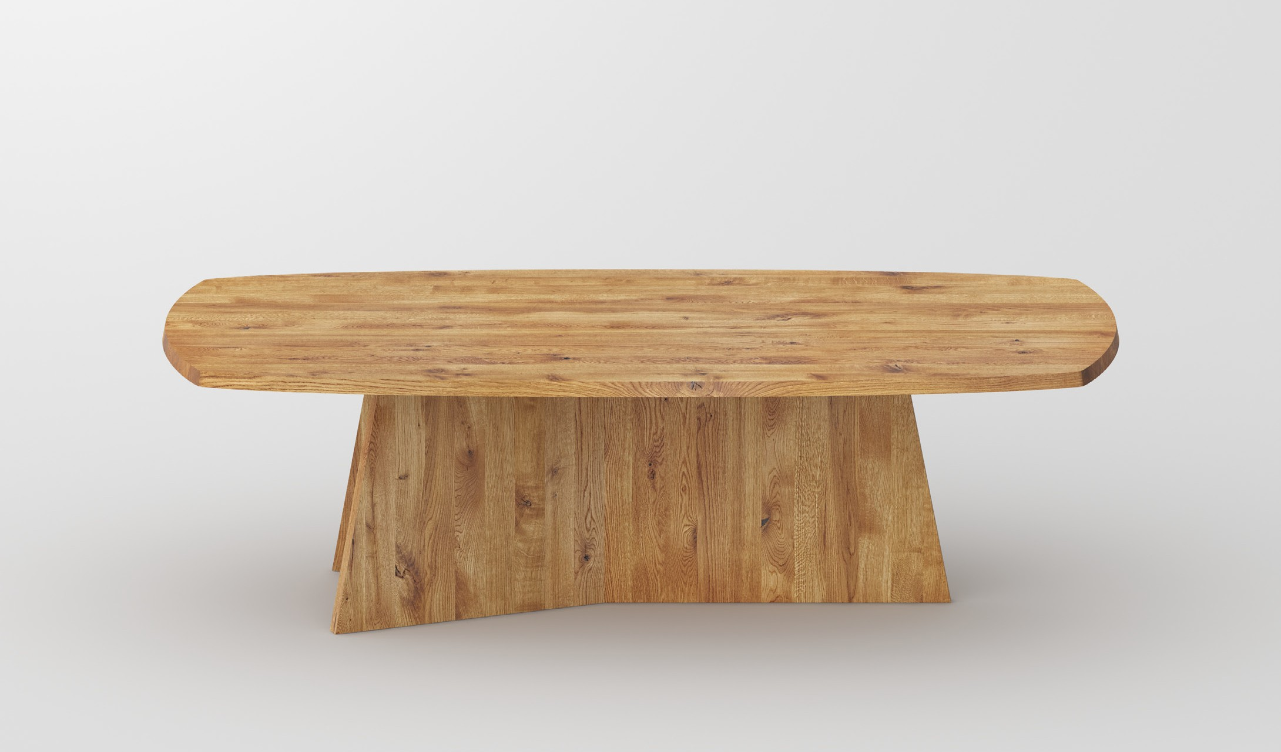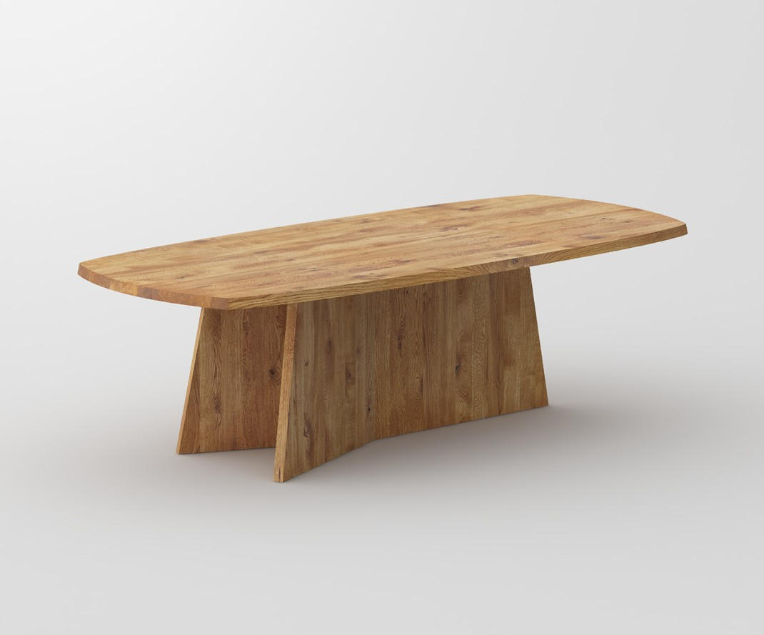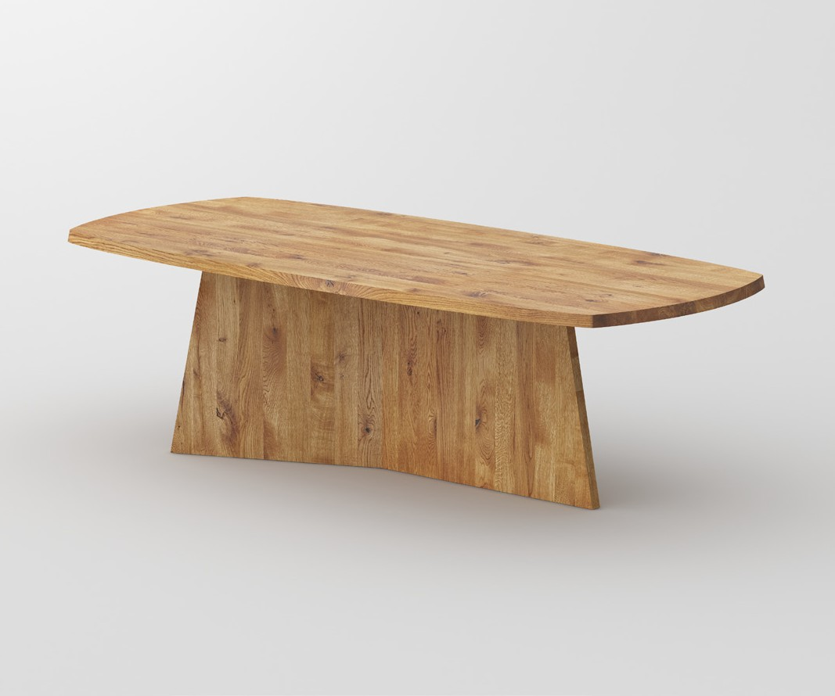

PRESS RELEASE

**Table LOTUS**

**Pure elegance, purity and architectural strength.**

The authentic look gives the table LOTUS a strong expression – ideal for modern living spaces.

The prominent frame and the extraordinary sloping table top are characteristic features, giving the table lightness at the same time robustness with high recognition value.

Available in all solid wood types from vitamin design collection: European oak and knotted oak,

ash, beech, core beech, American maple, walnut and cherry wood, treated with herbal oil.

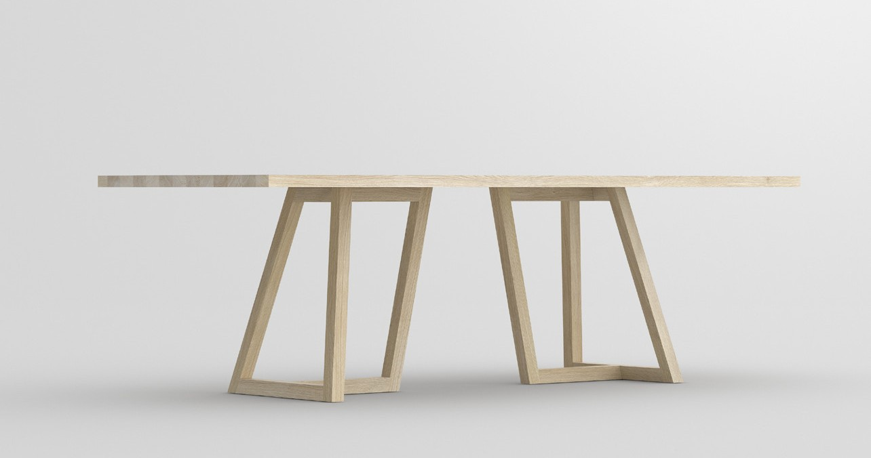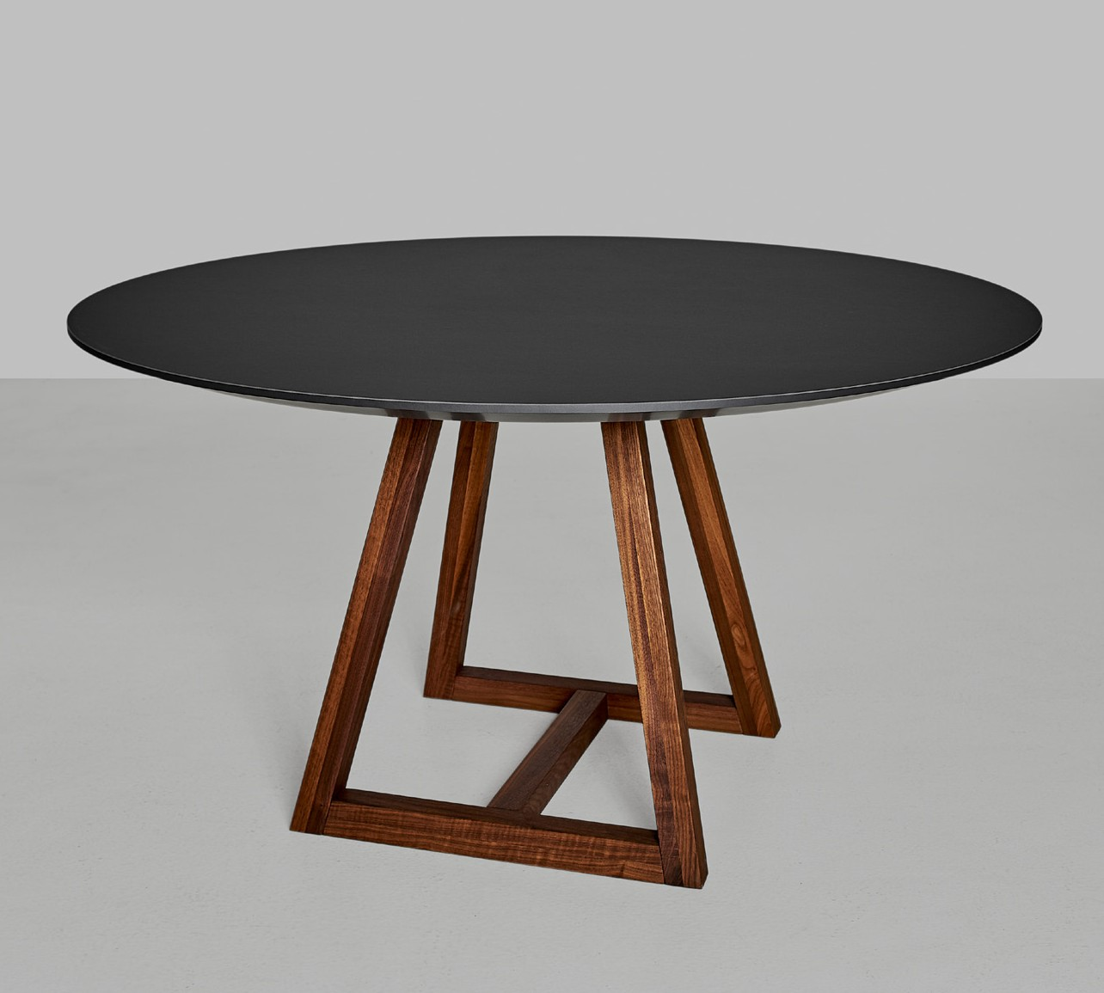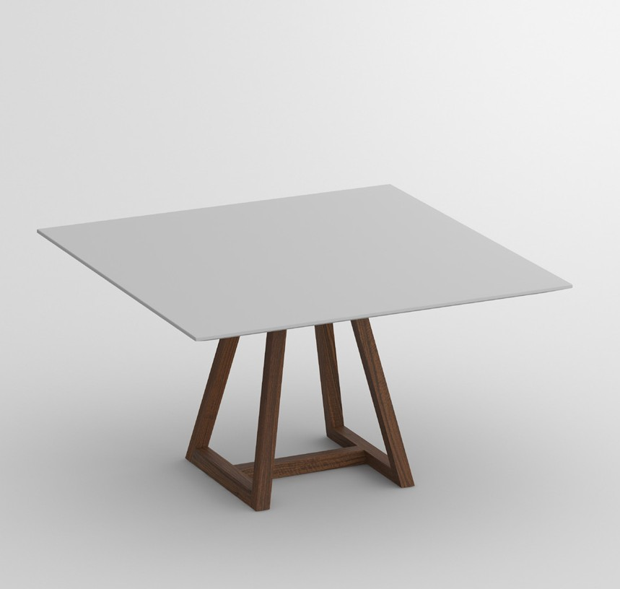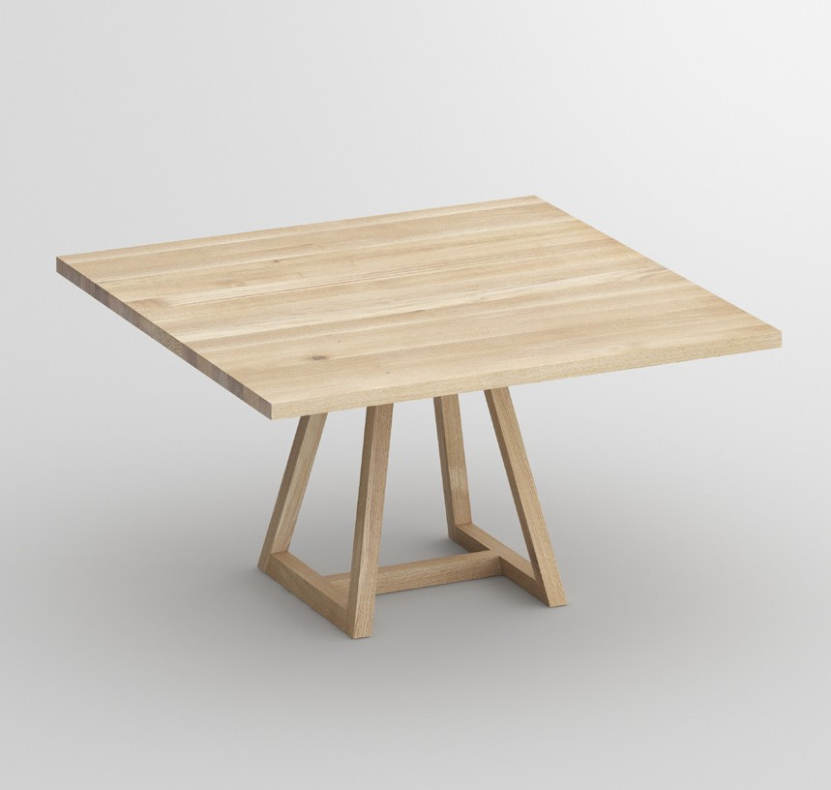

PRESS RELEASE

**Table MARGO**

**well-balanced bearing structure**

The evolution of the multiple award-

winning table MARGO iF Deisgn Award, ICONIC AWARDS 2017 und German Design Award 2017.

At first glance the graphic quality of

the table‘s modern form appears. The structural elements are defined by clarity of line. The awarded design elements have been refined with a clear, minimalistic round or square table top made of solid wood or linoleum, completing the graphical expression. The edge profile is made by individual choice with straight or chamfered edge.

Available in all linoleum and solid wood types from

vitamin design collection: European oak and knotted oak, ash, beech, core beech, American maple, walnut and cherry wood, treated with herbal oil.

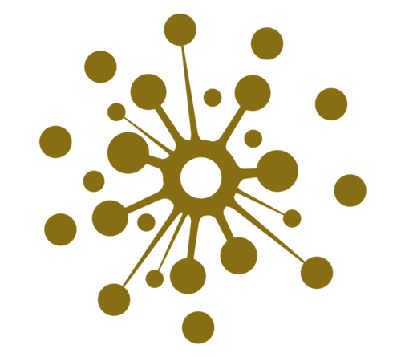

**GERMAN BRAND AWARD WINNER**

**VITA** - LIFE

**MIN** - MINIMALISM **VITAMIN** - HEALTH **DESIGN** - CREATION

vitamin design - nature friendly minimalistic design.

vitamin design was honored with the German Brand Award of the German Design Council

for outstanding brand management.

**Digital network with vitamin design**

The restructuring of all business units into digital processes is for

every company an important topic with a huge potential. We of- fer a solution to implement individual content management with innovation, functionality and data integration. The consumer has the liberty to get the desired information at anytime and any- where. All products and information are just a click away.

**About vitamin design**

vitamin design team designs and produces solid wood furniture with that certain

something. G. Grabliauskas, the company’s founder and designer, works very close with his team and has a long-standing experience and knowledge to develop a wide range

of demanding solid wood furniture. Thanks to their up-to-date design the prospective classics from vitamin design are subtly presented based on ecological requirements and timeless modernity. Based on in-house and on close cooperation with selected manufac- turers, vitamin design ensures his high performance and quality standards. Therefore the focus lies on flexibility, clear design and enhanced functionalities.

Press releases:

[www.vitamin-design.com/press](http://www.vitamin-design.com/press)

Press contact:

Gintaras Grabliauskas Dona Handelsges. mbH Grosse Elbstrasse 40

22767 Hamburg

Germany

+49 (40) 31798362

[info@vitamin-design.com](mailto:info@vitamin-design.com)

[www.vitamin-design.com](http://www.vitamin-design.com/)